**USING RAPTOR –DISPLAY PRIME NUMBERS BETWEEN 1 AND 100**

**ANIRUDH.R(192011013)**

**FLOWCHART**

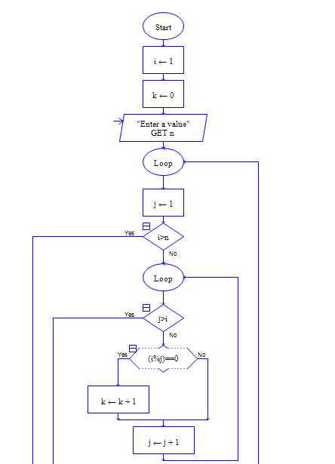

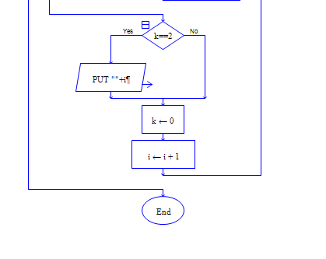

**INPUT**

100

**OUTPUT**

